**Machine Learning Applied to Human Activity Detection For E-Health Using Wearable sensors or Android Phones**

**Abhay Swarnkar**

Date: 12-12-2022

**ABSTRACT:**

Now Days, very difficult problem to predict Human Activity such as walking, sitting, standing, walking, running and more. If we can right prediction with high accuracy then use that prediction various application such as Smart Homes, E-health(Fitness and sports, remote patient monitoring, Fall Detection and prevention Behavioural Health Monitoring. etc), Security and Surveillance. Education. A novel KNN-SVM human activity detection method is proposed to detect human activities in the UCI dataset for complex multi-process physical activities. Model trained with machine learning algorithms to capture the temporal dependency, normal sequences with high dimension is uniformly utilized to train the model to discriminate each activity. In the classification Process, 2 different efficient classifiers are applied to identify the types of human activities in the UCI dataset. Support Vector Machine and K-Nearest Neighbour are applied in the proposed method for the classification. The efficiency of each classifier is about 85% to 87%. The classification efficiency is comparable with existing literature after applying the majority decision in these classification techniques.

**Keywords:** Machine Learning, Smart Homes, E-Health, Education , Security and Surveillance, KNN, SVM, Human Activity Recognition, HAR (Human activity recognition )

1. **PROBLEM STATEMENT:**

The Work Proposed in this report aims to instrument several applications Human Activity Prediction. Now Days, very difficult problem to predict Human Activity such as walking, sitting, standing, walking, running and more. If we can right prediction with high accuracy then use that prediction various application such as Smart Homes, E-health(Fitness and sports, remote patient monitoring, Fall Detection and prevention Behavioural Health Monitoring. etc), Security and Surveillance

* Healthcare
* Fall detection and prevention: HAR can be used to detect falls in elderly individuals or patients with mobility issues, triggering automatics emergency responses.
* Activity Monitoring: Tracking and analysing daily activities can provide valuable insights into a person’s health and well -being, aiding in preventive healthcare.
* Fitness and Sports: In sports, HAR can analyse movements to evaluate and enhance athletic performance.
* Smart Homes:
* Gesture Control: HAR can enable gesture-based control of smart home devices, enhancing user convenience and accessibility. For example, your sit in front of TV then TV switch on automatically
* Energy Efficiency: Analysing human activities can contribute to smart homes system that optimize energy based on occupancy patterns.
* Security and Surveillance
* Intruder Detection : HAR can help identify suspicious activities or intruders in restricted areas through the analysis of human movement patterns.
* Access control: HAR can enhance control systems by recognizing authorized personnel based on their activities.

Human Activity Prediction has found application in various field due to its ability to analyse and understand human behaviour through data collected from sensors. The cell phones is assuming a crucial job in present day life. It offer types of assistance and application, for example, location tracking medical application and human activity examination, all android smartphones, have motion sensors i.e. Accelerometer, gyroscope, in order to detect motion of a user in a very precise way. In early conditions, committed sensors were utilized for activity acknowledgement. Different techniques are developed for distinguishing normal or human activities scenes in the crowd by processing the video or an image. It is the problem of correctly classifying the smartphones sensor observation into distinct activities. The reading record by sensor are taken in three dimensions (x,y,z). The HAR system can track of daily life human activities from simple to complex a thus render its services for different applications such as disease prevention, elderly monitoring, fall detection system and many more.

**2.0 MARKET/ CUSTOMER / BUSINESS NEED :**

Our main Objective in E-health Sector where hospital or personal Application can track human activity for Elderly person to prevention falling from slip and stumbling or other reason.

**2.1 Market Opportunity:**

* Recognize the growing market opportunity for innovative solutions in the healthcare and wellness sector.
* Address the increasing demand for technologies that focus on fall prediction and prevention, catering to a broader consumer base.

**2.2 Proactive Healthcare Approach:**

* Align with the trend towards proactive healthcare by developing a solution that focuses on predicting and preventing falls.
* Position the offering as a strategic initiative for healthcare providers aiming to shift from reactive to proactive patient care.

**2.3 Aging Population Demands:**

* Cater to the needs of an aging population that seeks personalized and preventive healthcare solutions.
* Recognize the demographic shift and design the solution to address the unique health challenges faced by the elderly.

**2.4 Wearable Technology Integration:**

* Explore the integration of wearable devices equipped with fall prediction capabilities.
* Tap into the wearable technology market, providing users with unobtrusive and continuous fall monitoring.

**3.0 EXTERNAL SEARCH ( ONLINE INFORMATION SOURCES / REFERENCES/LINKS)**

I use Human Activity Recognition with Smartphones for this Project: Dataset can be found here:

[Human Activity Recognition with Smartphones (kaggle.com)](https://www.kaggle.com/datasets/uciml/human-activity-recognition-with-smartphones/data)

The Dataset can be found on the Kaggle. The dataset consists The experiments have been carried out with a group of 30 volunteers within an age bracket of 19-48 years. Each person performed six activities (WALKING, WALKING_UPSTAIRS, WALKING_DOWNSTAIRS, SITTING, STANDING, LAYING) wearing a smartphone (Samsung Galaxy S II) on the waist. Using its embedded accelerometer and gyroscope, we captured 3-axial linear acceleration and 3-axial angular velocity at a constant rate of 50Hz. The experiments have been video-recorded to label the data manually. The obtained dataset has been randomly partitioned into two sets, where 70% of the volunteers was selected for generating the training data and 30% the test data. The sensor signals (accelerometer and gyroscope) were pre-processed by applying noise filters and then sampled in fixed-width sliding windows of 2.56 sec and 50% overlap (128 readings/window). The sensor acceleration signal, which has gravitational and body motion components, was separated using a Butterworth low-pass filter into body acceleration and gravity. The gravitational force is assumed to have only low frequency components, therefore a filter with 0.3 Hz cutoff frequency was used. From each window, a vector of features was obtained by calculating variables from the time and frequency domain.

**4.0 HARDWARE AND SOFTWARE REQUIREMENTS**

**4.1 Hardware Requirements:**

**4.1.1 Minimum Requirements:**

**1. Android Device:** Compatible Android smartphone or tablet with a minimum Android version supported by your development framework.**2. Sensors:**

* Accelerometer: Essential for detecting motion and changes in speed
* Gyroscope: Helps in measuring orientation and rotation.
* Magnetometer: Provides data on the device's orientation with respect to the Earth's magnetic field.

**4.1.2 Recommended Additional Hardware:1. Wearable Devices:**Smartwatches or fitness trackers with sensors for extended data collection and user convenience.

**4.2 Software Requirements:**

* + 1. **Development Environment:**

1. Integrated Development Environment (IDE):Android Studio: The official IDE for Android app development.
2. Programming Language: Java or Kotlin: Standard languages for Android development.
   * 1. **Software Libraries and Frameworks:**
3. **Android SDK:** Software Development Kit providing necessary tools and libraries for Android development.
4. TensorFlow or PyTorch or Sci-kit Learn: Machine learning frameworks for implementing and deploying activity recognition models.
5. Google Play Services: For accessing location services, if needed.
   * 1. **Activity Recognition Model:**
6. **Activity Recognition Model:**Implement or integrate a pre-trained machine learning model for activity recognition. In Sci-Kit Learn, KNN, SVM, Random Forest may be suitable for model deployment on mobile devices
   * 1. **User Interface (UI) Design:**
7. **UI/UX Design Tools:**

Graphic design tools for creating an intuitive and user-friendly interface. For example, Adobe XD, Sketch, or Figma.

**4.2.5 Back-End (Optional):** **1. Back-End Server (Optional):**

If your app involves cloud-based processing or data storage, you may need a back-end server.**2. Connectivity (Optional):**Bluetooth or Wi-Fi (Optional): If your app communicates with external devices or sensors, such as wearable devices.

**5.0 FINAL PRODUCT PROTOTYPE (ABSTRACT ) WITH SCHEMATIC DIAGRAM**

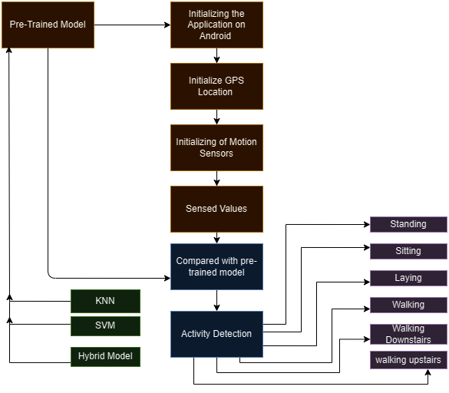

**5.1Model Work with Sensor to prediction**

**5.1.1 Pre-Trained Model: -**

Here we are using Multi-Classification model such as KNN(K-Nearest Neighbour ), Random Forest Classifier, SVM(Support Vector Machine) or We are use more than one Machine Learning Hybrid Model.

**5.1.2 Initializing the Application on Android : -**

Initializing the Application Fronted with help React Native, Android Development Java. App connected with backend help of API connected. To help that

**5.1.3 Initialize GPS:**

Before the activity detection process can begin, the GPS sensor on the Android device needs to be initialized. This involves establishing communication with the hardware, configuring its parameters, and requesting location updates at a desired frequency. The GPS sensor plays a critical role in several aspects of activity detection. Firstly, it provides the user's location information, which can be used to differentiate between activities performed in different environments (e.g., walking outdoors vs. walking on a treadmill). Additionally, location data can be factored into the model's feature extraction process, potentially improving its accuracy for certain activities. Initializing the GPS involves several technical considerations. The app needs to request permission to access the user's location, and the chosen location provider needs to be specified (e.g., GPS, network, fused). Additionally, the desired accuracy and update frequency need to be configured, balancing battery life with data freshness.

**5.1.4 Initializing of Motion Sensors**

The Android device's numerous motion sensors must also be initialised before activity detection can start, much like the GPS does. These sensors, which provide useful data on the user's movement, usually consist of magnetometers, gyroscopes, and accelerometers. The Earth's magnetic field is measured by the magnetometer, angular velocity is measured by the gyroscope, and linear acceleration is measured by the accelerometer. Just like with the GPS, each motion sensor must be initialised. The application configures the relevant sensor characteristics, such as sampling rate and sensitivity, and asks for permission to access the sensors. It also chooses the suitable sensor provider. Additional settings, like calibrating the gyroscope or adjusting the magnetometer's reference frame, can be required depending on the sensors that are accessible on the device. The information gathered from these sensors is essential to the task.

**5.1.5 Sensed Value**

The programme begins actively sensing values from the GPS and motion sensors at a predefined frequency when all sensors have been initialised. In order to balance the trade-off between obtaining comprehensive information and prolonging battery life, this frequency is essential. For instance, whereas walking or standing can be detected at a lower frequency, recording fast motions during sprinting might require a higher frequency. In order to perform sensing, data is usually retrieved from the sensor drivers and buffered for further processing. Depending on the kind of sensor, the format in which the data is stored varies, but timestamps, unprocessed sensor readings, and maybe more calibration parameters are frequently included. To guarantee data continuity and integrity, the application must provide strong error management.

**5.1.6 Compared with pre-trained Model**

The activity detection procedure, which involves comparing the pre-trained model with the features that were collected from the sensor data. This stage is crucial because it enables the model to categorise the user's behaviour into one of the established classes (e.g., standing, sitting, walking, running, etc.) by using its expertise. The collected features are usually fed into the input layer of the model and spread throughout the network as part of the comparison process. The intrinsic architecture of the model extracts higher-level representations from the features through intricate computations carried out by its network of connected neurons and activation functions. The network's last layer generates a probability distribution for every activity type, showing how confident the model is in each prediction. The anticipated activity is then chosen as the activity class with the highest likelihood.

**5.1.7 Activity Detection**

The final step is to predict the user's activity based on the model's output. This typically involves selecting the activity class with the highest probability. The predicted activity can then be used by the app to provide feedback to the user or to take other appropriate actions.

**5.2 Block Diagram :**

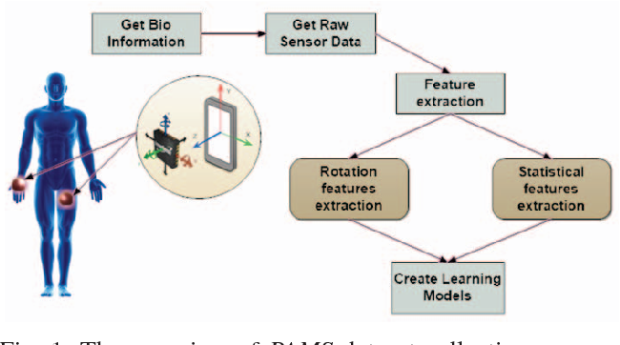

**5.2 Block Diagram of Sensor-Based human Activity Recognition Using**

**6.0 MODEL:**

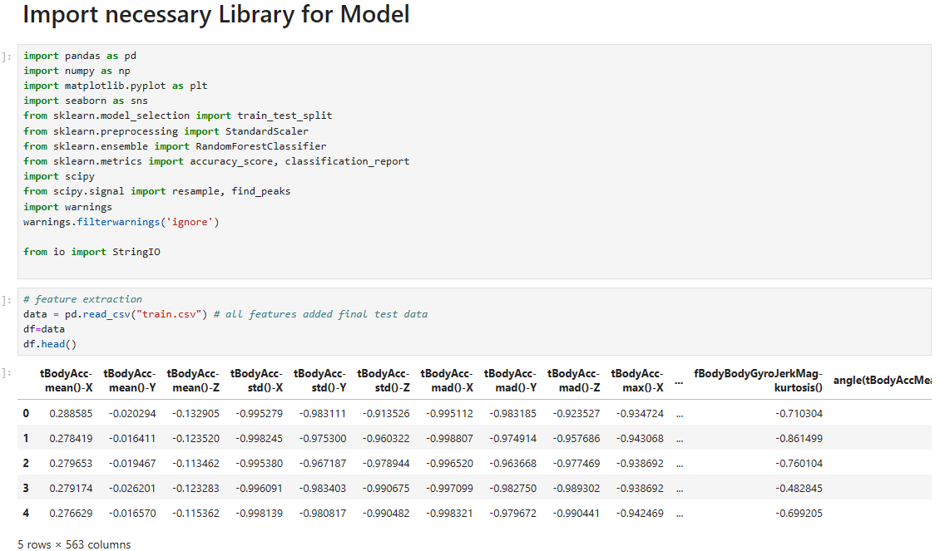

**6.1 Import Library and Dataset in Jupyter Notebook**

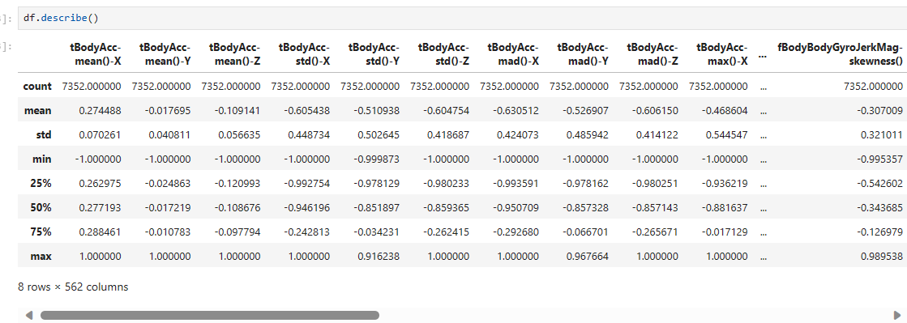

**6.2 Describe Dataset**

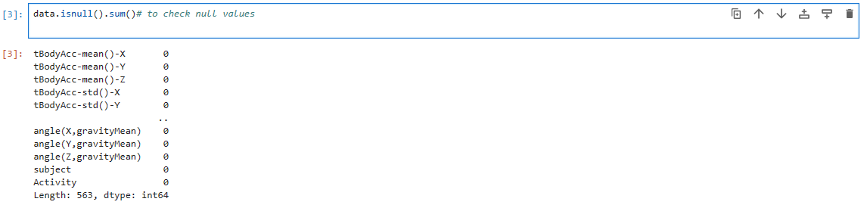

**6.3 Check Datasets does not contain Null value**

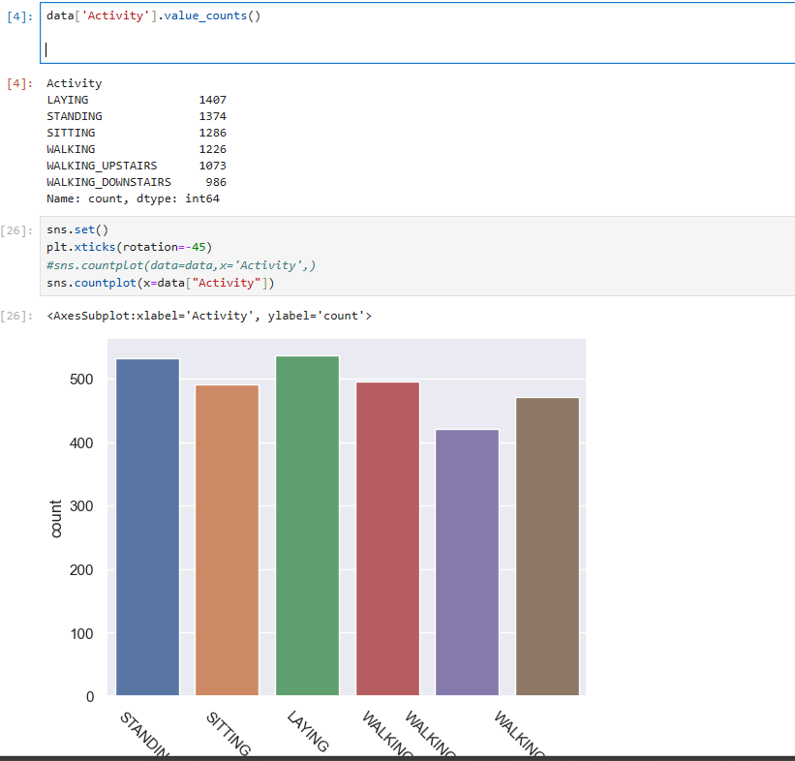

**6.4 Target value count**

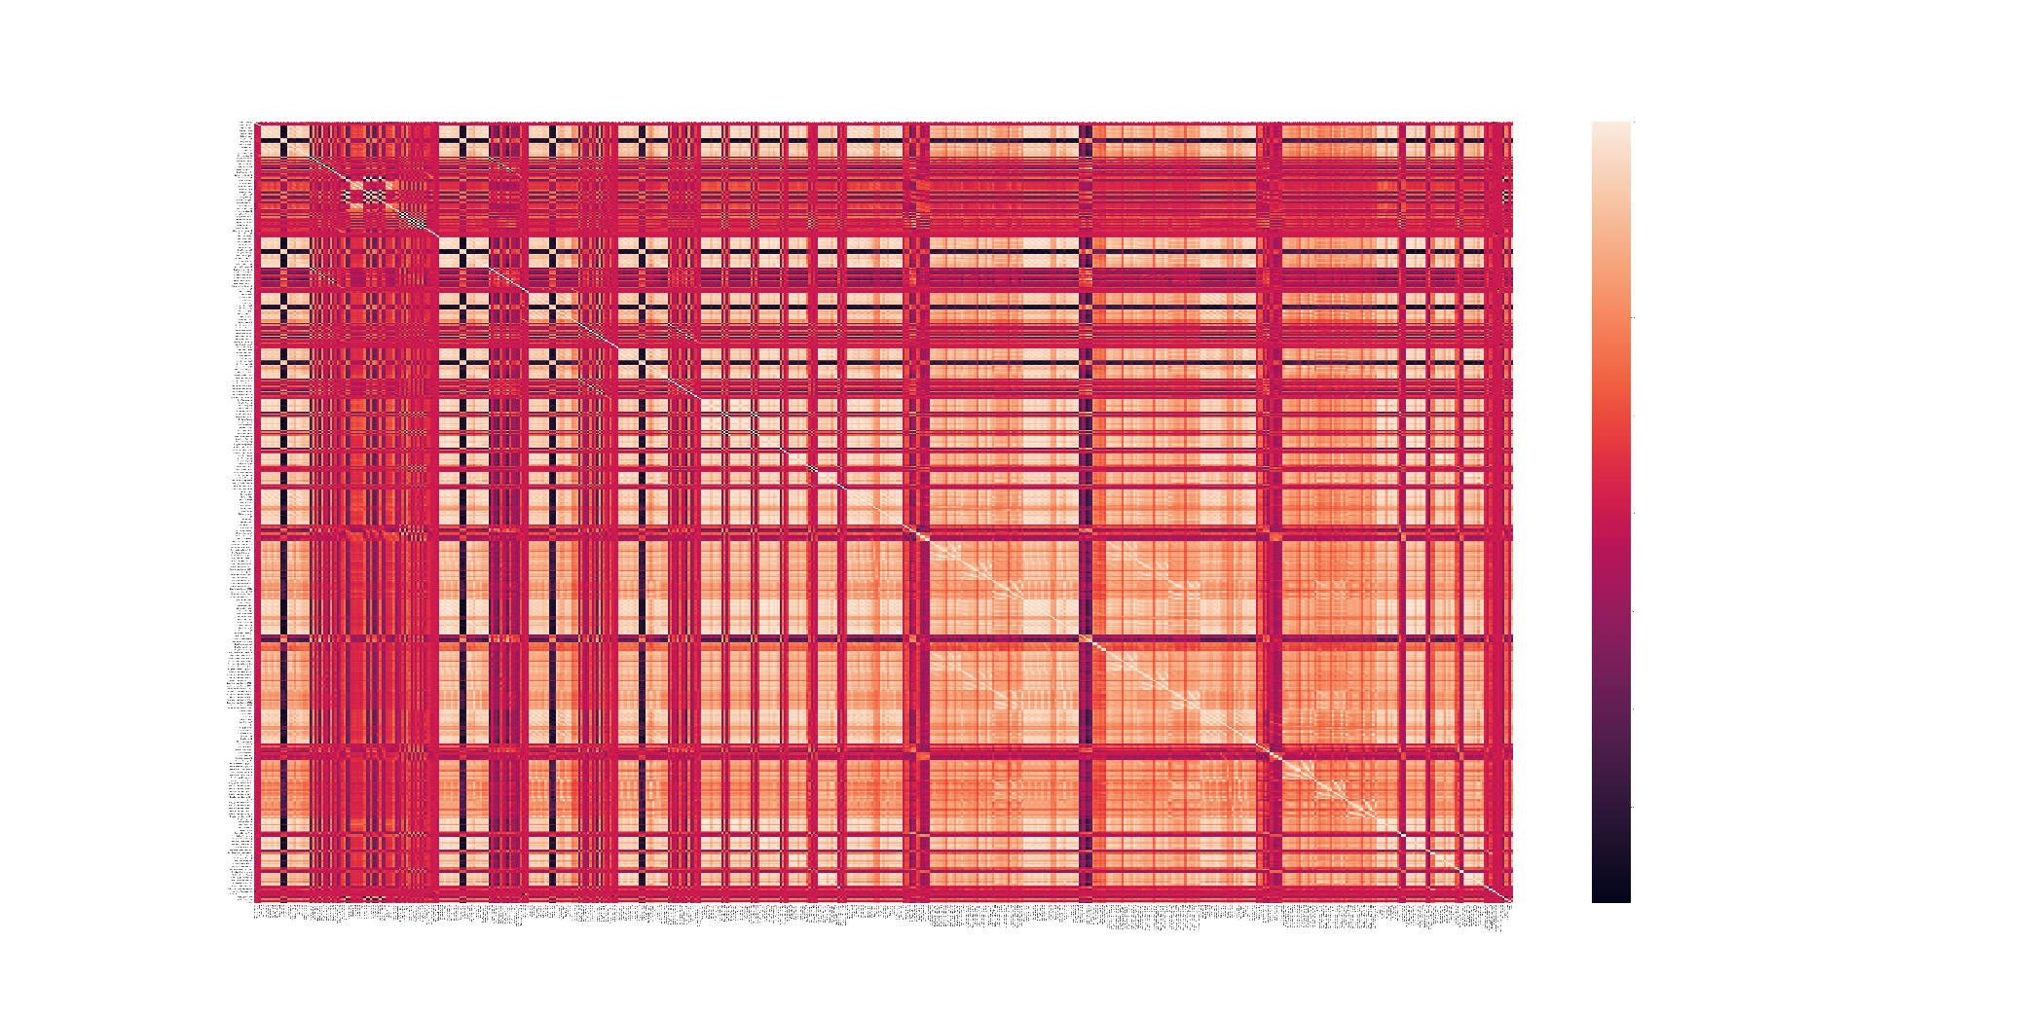

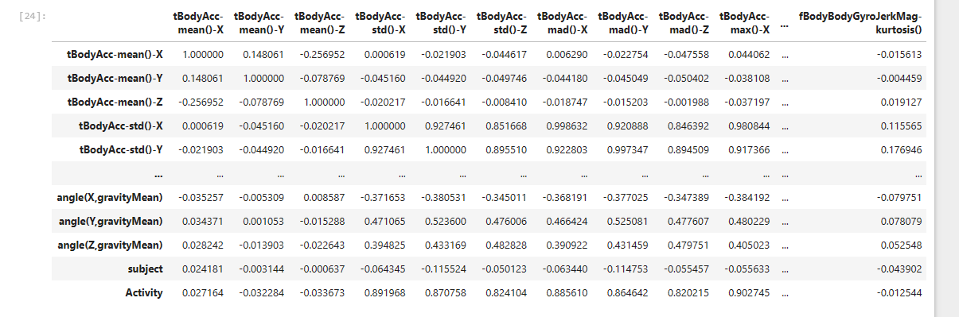

**6.5 Heatmap of correlation**

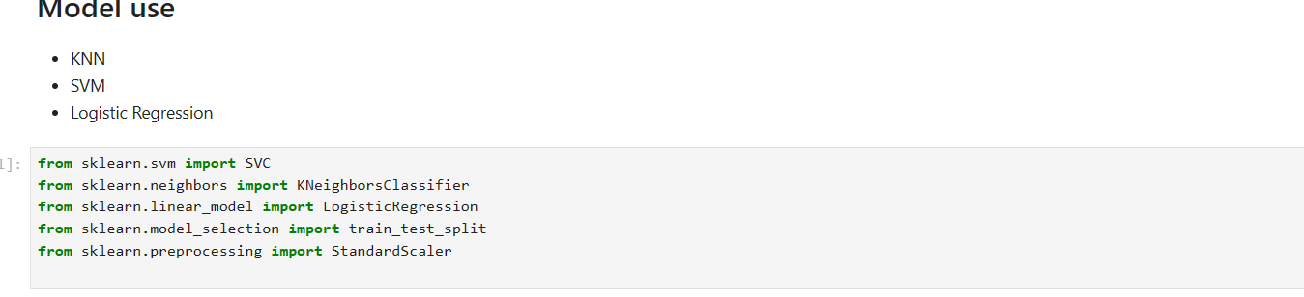

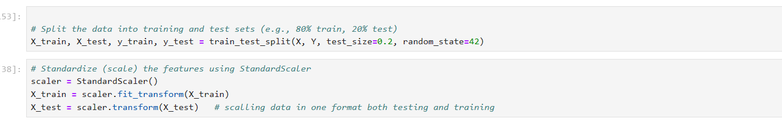

**6.6 Split dataset train and test, normalize**

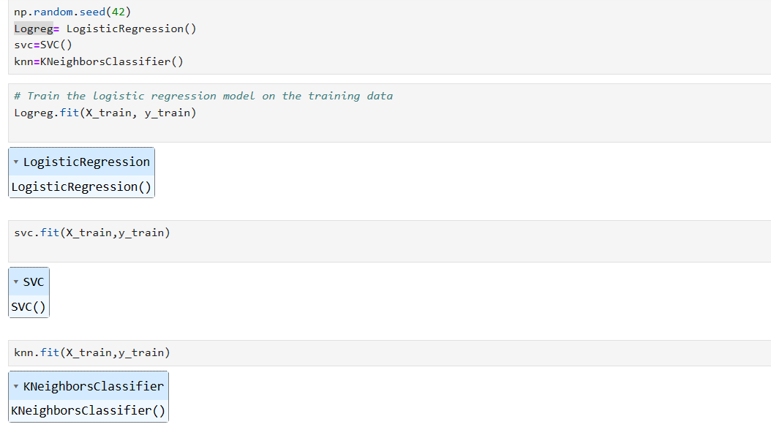

**6.7 Train model**

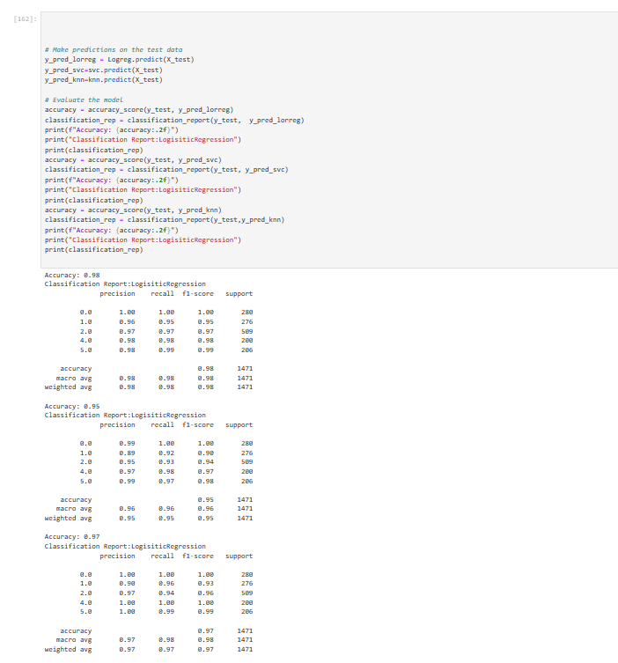

**6.8 Accuracy and Report**

**CONCLUSION**

The study proved the feasibility and usefulness of using machine learning techniques to detect human activity in the e-health area. The combination of wearable sensors and Android phones creates a scalable and user-friendly platform for health monitoring and promotion. This technology has a lot of potential for supporting healthcare workers in making informed decisions, increasing patient outcomes, and enabling more tailored healthcare delivery. Further development of the machine learning models, constant data validation, and collaboration with healthcare experts will be required in the future to improve the accuracy and reliability of the system. Furthermore, addressing privacy and security precautions is critical for widespread use of such technologies. Overall, the project has established a solid basis for the junction of machine learning and e-health, paving the way for novel approaches solutions in the broader healthcare landscape. But use more accurate use of Deep Learning Concept to make model as CNN, ANN etc then model are more accurate.

Key Findings:

1. **Accurate Activity Detection:** The application of machine learning models to data collected from wearable sensors or Android phones has shown promising results in accurately detecting various human activities. This includes but is not limited to walking, running, sitting, and sleeping.
2. **Versatility of Data Sources:** The versatility of utilizing both wearable sensors and Android phones as data sources provides flexibility and accessibility. Wearable sensors offer continuous monitoring, while the prevalence of smartphones allows for widespread adoption of the system.
3. **Real-time Monitoring:**The integration of machine learning models allows for real-time monitoring of human activities. This is crucial for timely intervention, especially in healthcare scenarios where prompt responses to changes in activity patterns can lead to improved patient outcomes.
4. **Potential for Remote Patient Monitoring:**The project has laid the foundation for remote patient monitoring applications. By leveraging machine learning algorithms and readily available devices, healthcare providers can remotely track patients' activities and health status, contributing to more proactive and personalized healthcare.